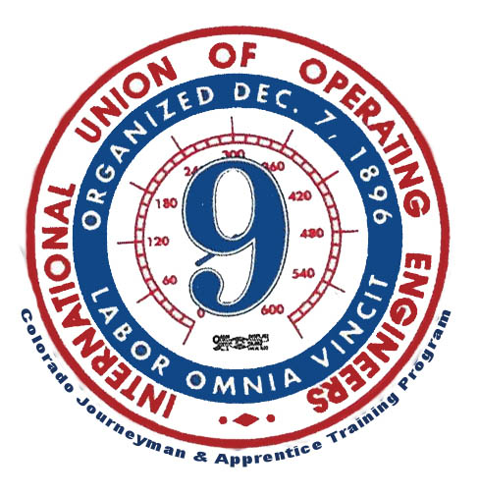
NCCCO Written Prep
Instructor | Email | Office Location & Hours
Corey Thieman | cthieman@cjatiuoe.com | 41801 E Quincy Ave.  Bennet, Co 80102  Tue-Sat 7:00am-3:30pm  303-644-3909
  - Winter 2020-2021

Crane Course Information

This Course is designed for those members wishing to attain NCCCO certification. Registration for this course is required and due by 19 December 2020. NCCCO Candidate applications are due no later 16 January 2021. Candidate Applications may be completed on the first day of class.
Crane Course Schedule
Week | Topic
Saturday, 16 January 2021 | This course will cover basic rigging and signaling to prep the member for taking the NCCCO mobile crane operator written exam
Saturday, 23 January 2021 | This Course will cover crane basics. Set up and operations of a mobile hydraulic crane; to prep the member taking the NCCCO mobile crane operator written exam.
Saturday, 30 January 2021 | This course will cover crane basics. Set up and operations of a mobile lattice crane; to prep the member taking the NCCCO mobile crane operator written exam.
Saturday, 06 February 2021 | Members can expect to take a complete mock exam. A mobile crane operator core exam and specialty exams of their choice.
Sunday, 7 February 2021 | A NCCCO chief examiner will administer the NCCCO mobile crane operator written exams.

Important Dates
Date | Subject
19 December 2020 | Registration for crane class is due.
16 January 2021 | NCCCO Applications Deadline
7 February 2021 | NCCCO recertification written test

